Model text: The Old Mill A suspense story
Stealthily, Jo crept down the stairs, dodging the fourth step in case it creaked. At the bottom she paused, but all that she could hear was a silence that consumed the house. The cat wound its way round her legs and they locked eyes. He was begging to be let out.
Twenty minutes later, she entered the forest. Tall trees towered overhead, their branches reaching out to escape, their leaves wilting, dying. As daylight filtered through the branches, it cast ebony shadows along the narrow winding pathway. It wasn’t long before she reached the ruins of the old mill: the one she had heard so much about. The pond in front of the mill glittered in the sunlight. A few bees buzzed busily.
Jo sat down under the protective trees and watched as the dragonflies flitted across the surface of the pond. All was calm. All was quiet. It was here that she had first seen it. All morning she waited, until in the end her eyes closed and she slowly drifted off into a gentle sleep.
She woke with a start to the sound of the wind whispering in her ear. Jo shuddered. When she opened her eyes, she realised that the sun had slipped behind the trees, casting charred shadows across the water’s oily surface. A twig broke, leaves rustled and something moved towards her.
Cautiously, Jo stared into the darkness between the trees where her mind warned her anything could exist. A jet black silhouette then darted, followed by a sudden hiss and a flicker of red eyes. Jo gasped.
Jo ran. Branches whipped at her face; brambles tore at her feet; thorns stabbed her sides and she felt like she couldn’t escape. She was sure that she could hear something behind her. What was it? Who was it?
It was only when she reached the road beyond the tree line that she stopped. She wheezed, bent over clutching her side. All she could hear was her heart thudding. Nothing else. Nobody else. The forest was still. It was as if the forest had swallowed its secret.

Model text: The Conrad, Maldives Persuasive writing
Do you want an escape? Do you want to draw the curtains in the morning and see nothing but the crystal-clear Indian Ocean? Do you want a holiday of a lifetime? Of course you do. Recently voted as the Maldives’ top luxury retreat in the world’s most sought-after holiday destination, The Conrad resort really is the ideal escape for you and your loved ones.
This beautiful part of the world can offer you endless relaxation and the most breath-taking views. Say goodbye to the stresses and strains of your everyday life; say hello to a new way of living. The Conrad resort not only offers you rolling white beaches and a warm, inviting ocean, but it also has a 5-star spa just minutes away from your waterside villa. Prefer a more active holiday? No problem! There is much to offer more adventurous holiday makers: snorkelling with turtles, sailing in glass bottom boats, beach fitness classes and cycling adventures. The list is never ending! What more could you ask for?
Now, you may be thinking, there’s no chance I can afford to go somewhere like that, nor can I afford the flights. Well, you are wrong. Simply pay a visit to our website; you will be pleasantly surprised by the packages and prices on offer. We want everybody to be able to experience the Maldives’ indulgence and charm, regardless of their financial position.
Whether you decide to stay with us for a quick week retreat, or for a fortnight of formidable exploration, The Conrad resort will offer you an unforgettable experience and the opportunity to create memories which will last you a lifetime. So, what are you waiting for? Visit our website and get your holiday booked up: you wouldn’t want to miss out, would you?

Model text: The Time Slip Scarab A portal story
Year Five went to visit the Fitzwilliam Museum each year and this year was no exception. The guide stopped at each display to tell the children about the different artefacts. It was only when they reached the Egyptian display that Emily, who had spent most of the trip totally disengaged, became mildly interested. A scarab beetle caught her attention: glittering wings flickered in the light; greens and blues shimmered like an iridescent gemstone and elongated feelers stretched towards her. “Wow,” she whispered, analysing its beauty up close – her eyes transfixed.
As the group meandered into the Viking section, Emily hung back. She waited. As soon as the others had disappeared around the corner, she reached out her index finger and caressed the beetle. A stabbing pain suddenly travelled up her finger and spread across her hand.
“Ouch!” she winced, not believing a mere stroke could create such a feeling. It was as if she had been stung. A cloud of haze and confusion consumed her and as the blur began to dissolve, she realised she was standing at the edge of a desert. The Fitzwilliam Museum was no longer. Towering amber pyramids jutted upwards in front of her; white birds circled above, calling; a vast river oozed by and tall palm trees lined its edge. Emily gasped, for she knew exactly where she was: Egypt.
“It can’t be? Surely? This can’t be happening to me,” she uttered, here eyes wide with fear, confusion and sheer disbelief.
A procession wound its way from the river towards Emily. At the front, a tall, menacing man dressed as Anubis (god of the afterlife), wearing a jackal’s mask, strode towards her. Drums beat, rattles shivered and the procession sung a low chant. Six men carried a huge, golden stand on which there was a throne. A beautiful woman surveyed the procession from on high. She was the only person without a mask and she was staring right at Emily, pointing directly at her.
Without thinking, Emily dashed towards a door set into the closest pyramid. Inside, it was cool and dark; she ran down a passageway. Torches burned to light the way ahead. On the walls, she saw carved images - an owl, a fish and hieroglyphs that were hard to comprehend.
“Follow that girl!” bellowed a menacing voice a few feet behind her. She could hear voices shouting and the sound of running feet getting closer, but the way ahead was blocked. Spinning round, she found the jackal standing in her path. The mask appeared to grin. Her bottom lip quivered. A bead of sweat trickled down her spine.
Suddenly, something itched against her leg; a shiny beetle glittered. Emily recognised the greens and reds glimmering in the torchlight. She reached down, grabbed the beetle, which was quickly crawling away, and once again felt a hot, sharp stabbing pain and… there she was, back in the museum with Mrs Hardy striding towards her, pointing directly at her.
“Emily Argent for goodness sake, will you hurry up and re-join the group? Start paying attention. Come on.”

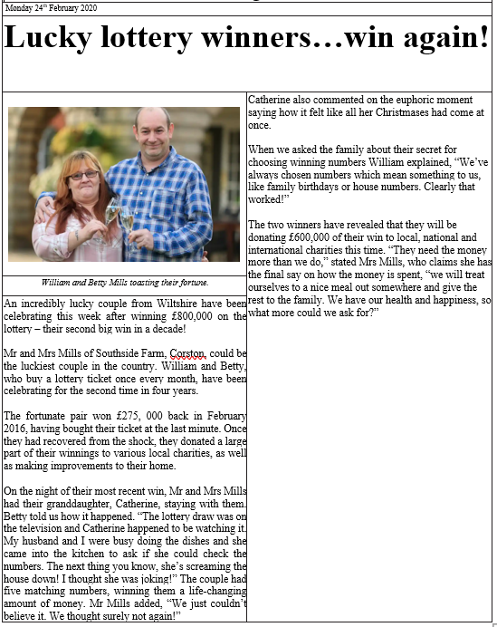
Model text: Lucky Lottery Winners… win again! A newspaper article

