
St Peter & St Paul CE Primary School, Eye

Friday 22nd October
Sports Newsletter

Dear Families,

Here is your first instalment of our Sports Newsletter for this academic year. We have had some great things taking place this half term and still more fantastic events to come.

Sport Squad

We have appointed 10 new fabulous Sport Squad leaders from Year 5 and 6 for this year. This year has seen the highest amount of applications with children showing their creativity and passion for Physical Education. We had written letters, Powerpoint presentations and even a few videos! The children have already had their first squad meeting where they have selected squad jumpers and lunchtime clubs for pupils.

Meet our Sport Squad:

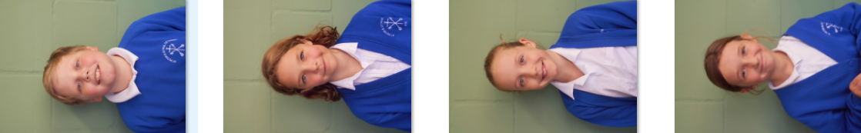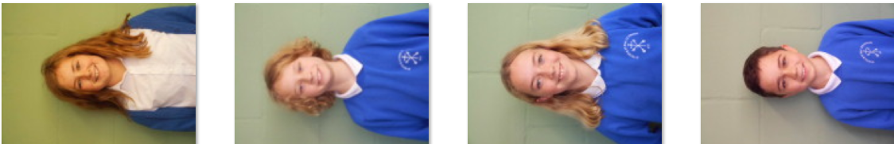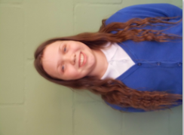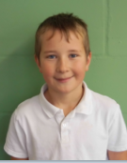

Sport Squad Activities at lunch:
Monday- Football Penalty Shoot out
Tuesday - Fitness
Friday – Rugby Skills

PE Provision

As a school we have continued to follow the Get Set 4 PE scheme. This provides teachers with great lesson planning, audio and visual resources to support pupils and staff training. As part of our PE, the children from KS1/2 also have an afternoon of Forest School. This supports objects for Physical Education in the national curriculum.

Enrichment Days

We have booked 12 exciting enrichment days so far for the year! These focus on specific sports, performing arts and PSHE related themes. So far this term, all pupils have taken part in a Roald Dahl experience and had a go at learning how to play Quidditch. Our next exciting sessions are:

Tuesday 9th November - Diwali
Friday 26th November- Fencing

Clubs

Next half term there will be more clubs on offer to our pupils. Football club for both KS1 and KS2 with Premier Sport coaches will continue with free places offered to pupil premium children. New members can sign up for these via

As well as Football club, we shall also be offering Gardening Club AND Dance Club.

Competitions

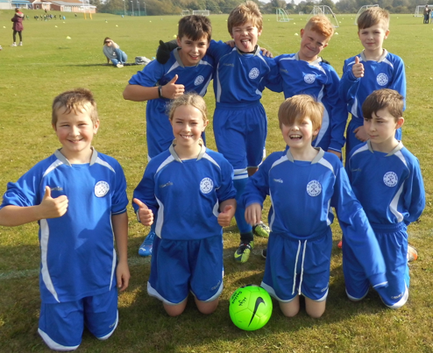
We have had great success at a local Cross Country; having 44 KS2 pupils take part. Every child showed determination and great support for others. We had many children within the top 10 and even had two through to county finals (well done Tilly and Jessica). Our school Football Team went up to Hartismere High School and came away with fourth place. They worked incredibly hard throughout the afternoon and showed amazing team work and sportsmanship. Well done!

Upcoming events include Tag Rugby, Multi Skills and Dance.

Special Events in School

We had so much fun completing our Mini Marathon in order to raise funds for Afghan Aid. Early Years and KS1 children took part in running at school whilst our KS2 pupils headed over to the Pennings for an afternoon of running. Everyone tried so hard; many smiling races were spotted as you ran! Together you have helped raise £669.60p for Afghan Aid, supporting refugees during an extremely difficult time. Thank you.

Special Thanks

Thanks to T800 Crossfit in Eye who gave us an amazing day of Crossfit back in the summer as part of our Healthy Living Week. We have used your donation to purchase equipment for lunch and play time and a playground storage box. This will help to keep us busy and active during our play times. We love them, thank you so much!

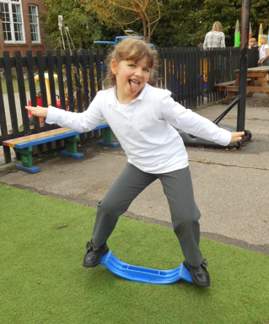
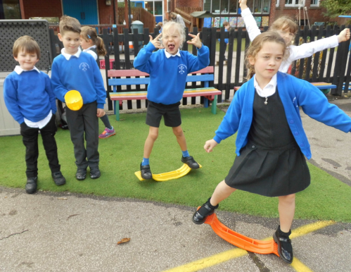
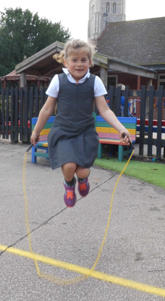

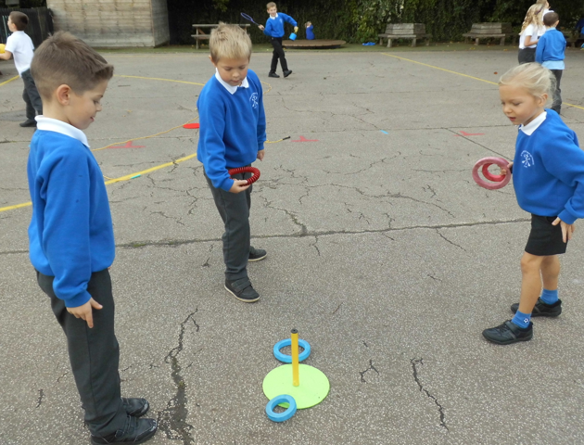

I hope you have enjoyed the newsletter, we shall keep you up to date on all our fantastic events and activities taking place in school.

Yours Faithfully,

Miss Hilton
PE Coordinator

