
St Peter & St Paul CE Primary School, Eye

Monday 13th December 2021
Sports Newsletter

Dear Families,

We have had such a busy half term in terms of PE within school. There has been so many great activities on offer for our pupils. Here is your next newsletter to keep you up-to date.

Sport Squad

Our enthusiastic squad have been busy with meetings, lunch time clubs and Sport awards. As part of their role as club leaders the children have begun to identify exceptional pupils who deserve certificates and medals for their efforts. These are awarded in line with the ‘Spirit of the Games’ which are:



Sport Squad Activities at lunch:
Monday- Football Penalty Shoot out
Tuesday – Fitness
Thursday - Basketball
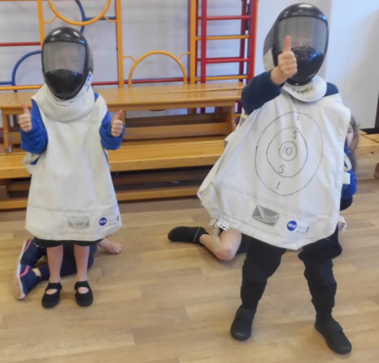
Friday – Rugby Skills

Enrichment Days

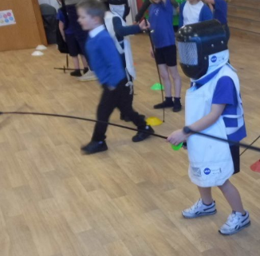
This half term we have experienced a performing arts Enrichment Day all about Diwali where we learnt how to dance for the festival of light. We also, all took part in a Fencing Sports Enrichment day. These were both so much fun and allowed all children to experience something new and exciting.
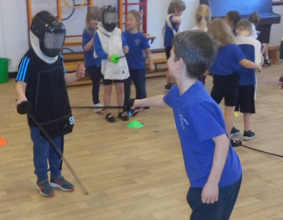

We have a further two Enrichment Days coming up for this coming half term:

Wednesday 12th January- Street Dance
Friday 28th January- Table Tennis

Clubs

Football club will now be on offer for all pupils with Early Years and KS1 (Reception/1/2) on Tuesdays and KS2 on Thursdays with Premier Sport coaches.
on Mondays for our KS2 pupils. All these clubs can be booked via parent mail with free places offered to pupil premium children or by visiting premier-education.com or 01953 499040

We shall also be offering an additional lunchtime club once a week with Premier Sport coaches offering games and activities linked to fundamental skills in order to provide pupils with more opportunities to take part in physical activity during their day at school.

PE linked after school clubs, please sign up via arbor:

Gardening Club Mondays
KS2 Dance Tuesdays

Competitions

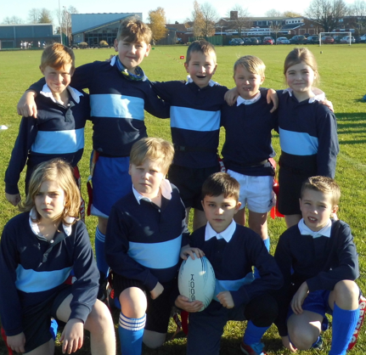
We have had continued success at local competitions with our Tag Rugby team winning the event and bringing home gold medals. A huge well done! You demonstrated great sportsmanship and teamwork. Event dates for the Spring term are being finalised so watch this space.

I hope you have enjoyed the newsletter, we shall continue to keep you up to date on all our fantastic events and activities taking place in school.

Yours Faithfully,

Miss Hilton
PE Coordinator

