
St Peter & St Paul CE Primary School, Eye

Thursday 17th February 2022
Sports Newsletter

Dear Families,

We have had a fun and busy start to the Spring term. Here is your latest newsletter to let you know how we have been keeping active and what exciting plans we have coming up.

Sport Squad

A huge well done to our Sport Squad who have continued to run activities during lunchtimes, awarding certificates and medals to those demonstrating elements of the ‘Spirit of the Games.’ Well done to all those who have won. Great work!
Following the break, The Sport Squad shall be offering new clubs:

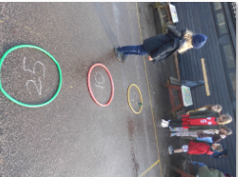
Tuesday- Fundamental Skills including dribbling, dodging, jumping and running.
Wednesday- Throwing and catching/ target games.

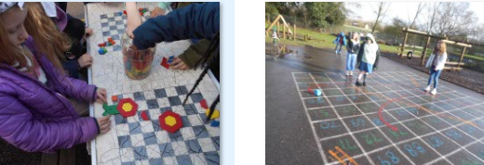
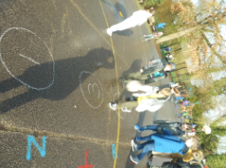
The Sport Squad also helped run PE activities with a Maths theme during our Number Day. These activities were very popular and lots of fun.

Enrichment Days

This half term we experienced Table Tennis and Street Dance, which gave us all the chance to try something a little bit different in school. Our next two are Wednesday 2nd- World Book Day Musical Theatre and Friday 18th- Kurling. We cannot wait!
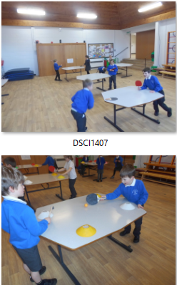

Clubs

Football club will continue to on offer for all pupils with Early Years and KS1 (Reception/1/2) on Tuesdays and KS2 on Thursdays with Premier Sport coaches.
All these clubs can be booked via parent mail with free places offered to pupil premium children or by visiting premier-education.com or 01953 499040

We shall also continue to offer an lunchtime club once a week with Premier Sport coaches offering games and activities linked to fundamental skills in order to provide pupils with more opportunities to take part in physical activity during their day at school.

PE linked after school clubs, please sign up via arbor:

Gardening Club - Mondays
KS2 Dance - Tuesdays
Netball (Yrs 4/5/6) – Thursdays

PE Lessons

Pupils continue to receive 2 PE sessions a week (1 for Reception) with our Year 4 class just completing their first swimming block. Year 5 shall be swimming after half term, with Year 3 and 6 continuing into the Summer Term. PE sessions are fun and challenging activities linked to progression of Fundamental skills. These may be linked to specific sports and performance and movement.

Competitions

We are excited to have some upcoming Sports Competitions with some intra sport and inter sport events for the younger years (dates to be confirmed). Those with confirmed dates are;

Ball Games- Thursday 9th March
Panathlon – Monday 28th March
Netball – Tuesday 29th March
Hockey- Monday 4th March

We look forward to another, fun and active half term,

Yours Faithfully,

Miss Hilton
PE Coordinator

